Html(Web Page), CSS and Bootstrap (apply styling for web page), JS(Client Side JavaScript).

Req (http/https)---------🡪

1st req

2nd req

3rd req

Client Server

🡨----------Res(http/https)

JavaScript is use to do validation on client machine or side.

All request are in queue.

Synchronous communication. The code or request get execute sequentially.

JavaScript Provided pre defined object ie XMLHttpRequest or ActiveXObject

AJAX : ASynchronous JavaScript and XML

ASynchronous

We can make our communication as Asynchronous means all our statement or function call or request execute independently.

Using AJAX concept frontend technologies load part of web page rather than whole web page.

Using Asynchronous and callback(Java8 with lambda expression).

Callback passing function name or function body or function itself to another function as a parameter is known as callback.

Using these two concept JavaScript achieve non blocking mechanism.

Java is thread base. In Java application request can be block.

Thread can be block.

If my tomcat application handle 100 client at the same time.

But JavaSCript using callback and asynchronous concept they can achieve non blocking concept.

Traditional Servlet, JSP , Spring MVC Spring boot MVC are thread base and they doesn’t support non blocking concept.

GOF

Reactive Programming : using reactive programming we can achieve asynchronous communication and non blocking mechanism in backend side technologies.

RxJS

RxJS is base upon Observable design pattern.

Subject : what type of data we want to produce it can be string, number, object like message.

Publisher : Publisher is responsible to publish the Subject or data.

Subscriber : Subscriber is use to get the data from publisher.

One to many relationship.

JMS : Java Message service

2 types of communication

One to one One to many

Queue container Topic container

“Every Dad need Mom”

Distributed Application Developer need Message Oriented Middleware like MQ or Apache kafka

To do reactive programming in Java.

We can use two base API

Mono : Mono produce 0 or 1 message or data.

Flux : Flux product 1 or many messages or data.

Using Mono or flux we produce the message or data.

These both API internally implements Publisher interface.

Then we need to subscribe those information.

HttpClient is api we use in angular framework to consume backend rest api. they use observable concept. To consume the using subscribe method which take 3 parameter

1. Load the data one by one onNext method
2. While loading any data if any error generate this onError method get called.
3. After loaded whole data successfully if we want to any task then this method get called. onComplete.

Spring boot with Reactive programming

1. Eureka Server

Starter 🡪Web

Starter 🡪Eureka

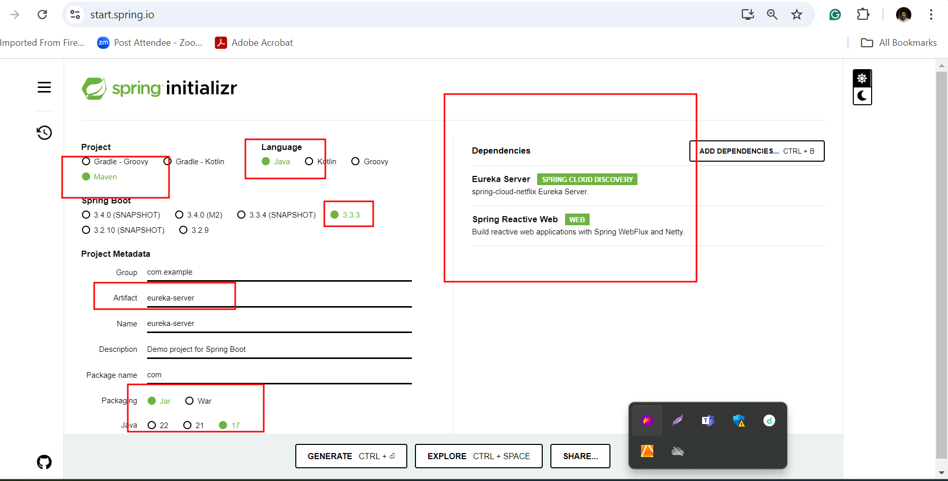

1. Creating reactive employee end point

